Abstract title in 12 pt bold Arial, Centered, with Capital First Letters
First Author^{1*}, Second Author² and Third Author³ (use Arial 11 pt)
¹Affiliation, Address, Country, ²Affiliation, Address, Country, ³Affiliation, Address, Country

Type the abstract title in upper and lower case letters (do not use all capitals letters) in the indicated line. Title should be written in 12 pt, bolded and centered. The presenting author's name must be underlined. Type authors names and affiliations in upper and lower case letters. Do not use titles; i.e. M.D., Ph.D., etc. Affiliations and addresses should be written in 10 pt fonts.
The size of the area is 160 x 120 mm². Text should be typed single-spaced, with 11 pt fonts in Arial. The first line of each paragraph should be indented by 1.2 mm. Do not leave blank lines between paragraphs. The text should be justified.
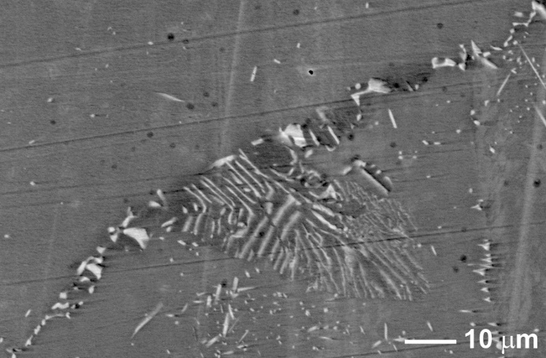
Use the SI system. Figures, tables and equations should be numbered with Arabic numbers and should be referred in the text as Fig., Table, Eqn. (with the proper number).
Fig 1. All figures and tables should have a proper caption in English with 9 pt fonts. The resolution of Figures should be between 150 and 400 dpi.
The references and acknowledgements should be written in 9 pt letters. The number of each reference should be in brackets and should be cited in the same way [1] in the text.
The abstract should be saved in pdf and uploaded.

[1] First Author et al., Journal/Proceedings Name Vol. No., page No. (publication year).
Acknowledgments should be placed at the end.

